Evaluación de Aprendizajes

20

Inglés para el trabajo

# Evaluación Continua 3

# Name: DAVID KENSHIN VEGA ORTIZ

1. Identify the parts of the house: (2p)

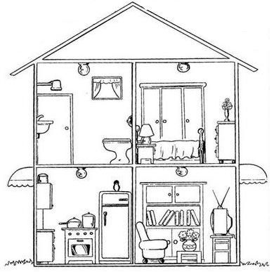

Bathroom

Bedroom

Living

Kitchen

1. Complete with the correct preposition of place: (6p)

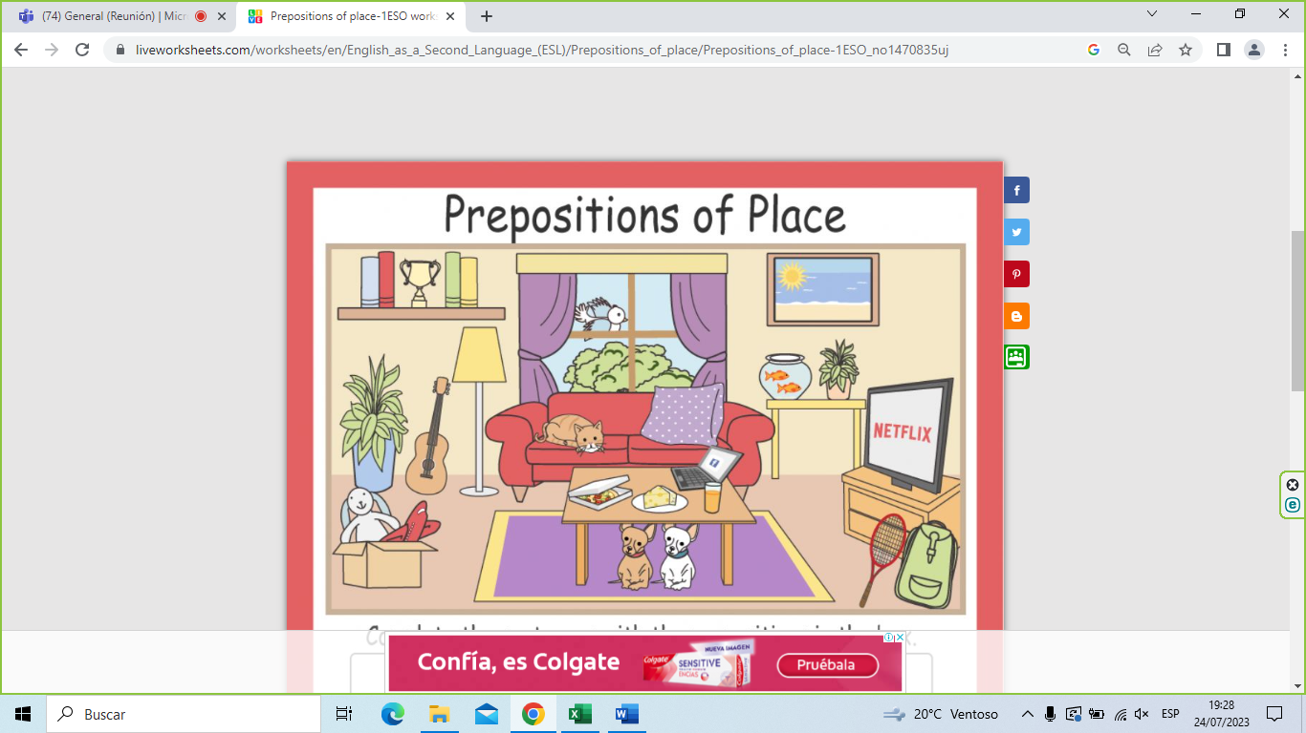

between

under

behind

next to

on

1. Write two sentences with there is, two sentences with there isn’t, two sentences with there are, two sentences with there aren’t: (8p)
2. There is a cat on the sofa
3. There is a pizza on the table
4. There isn't a parrot in the living room
5. There isn't a computer on the sofa
6. There are two chickens in my farm
7. there are three cats in my house
8. There aren't any dogs in the park
9. There aren't any laptops in my lab
10. Complete with was/ were/ wasn’t/ weren’t: (4p)
11. Agusto Polo Campos wasn't a soccer player.
12. Paolo Guerrero was in Argentina last month.
13. Gisela Valcarcela and Ethel Pozo were in The USA last week.
14. We were in Cusco last week.